6/25/2021

Matthew Saxton

Revised: 6/25/2021

Happy Minds

Software Project Management Plan

Contents

1.1 Project Overview 2

1.2 Project Deliverables 2

1.3 Evolution of the SPMP 2

1.4 Reference Materials 2

1.5 Definitions and Acronyms 2

2.1 Process Model 3

2.2 Organizational Structure 3

2.3 Organizational Interfaces 3

2.4 Project Responsibilities 3

3.1 Management Objectives and Priorities 4

3.2 Assumptions, Dependencies, and Constraints 4

3.3 Risk Management 4

3.4 Staffing Plan 4

3.5 Monitoring and Controlling Mechanisms 4

4.0 Technical Process 5

4.1 Methods, Tools, and Techniques 5

4.2 Software Documentation 5

4.3 Project Support Functions 5

# Project Overview

The purpose of this project is to create a web application that provides ease of access to mental health resources for users who struggle with mental health issues. Happy Minds offers assistance through one on one chat windows with trained professionals, a community forum for members to speak in a virtual safe space, and information on common indicators of mental health problems along with solutions and advice on how to tackle the respective concerns.

# Project Deliverables

The web app, in full, will be delivered by the presentation date, July, 19 2021.

# Evolution of the SPMP

The SPMP will be reviewed weekly to allow for a flexible and realistic management plan to ensure deadlines are met. All changes should be pushed to the SPMP and the repo to maintain an up-to-date plan.

# Reference Materials

List of materials in the SPMP

# Definitions and Acronyms

JS – Javascript

MERN – Software Stack for building dynamic web applications using MongoDB, Express JS, React, and Node JS.

CSS – Cascading Style Sheets for presentation of web documents.

NIMH – The National Institute of Mental Health

# 2.1 Process Model

Defined Requirements will impact the application development and design.

Will follow the Agile Software Development Model

Requirements -> Design -> Development -> Testing -> Deployment -> Reviewal

During the development and design process, testing will be carried out to ensure requirements are met.

After development and design are completed, site maintenance will be carried out.

# 2.2 Organizational Structure

The project in entirety is overseen and developed by Matt Saxton.

# 2.3 Organizational Interfaces

Code is written within the open source Visual Studio Code software. Common Node JS packages will be used to create the web application. An open source web API will display data on site.

# 2.4 Project Responsibilities

Matt will oversee the project in entirety.

# 3.1 Management Objectives and Priorities

Weekly progress following the listed priority schedule. The schedule is shown on the following Gantt Chart:

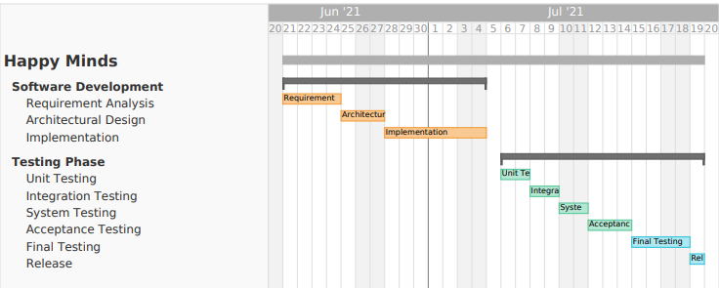

# 3.2 Assumptions, Dependencies, and Constraints

Assumptions/Constrains:

* Deadlines are consistently met
* The application must list official health information
* The specialists must be actual health professionals
* Forums must be maintained by site administrators and moderators to provide a virtual safe space

# 3.3 Risk Management

There are certain risks associated with working with users who struggle with mental health problems. The forums will need to be moderated to restrict trolls and certain triggers from negatively impacting site users. This can be easily monitored via a report feature that automatically disables a user who is reported by multiple users in a given timeframe. These reports can be reviewed by site administrators to determine if the report is a false positive or a genuine risk.

The site will need to adhere to HIPPA violations and not store data on users. The terms of services will inform members that their chats are private with healthcare professionals and only forum discussions will be public information. The site will not share cookies or other gathered information on the user with any third party.

# 3.4 Staffing Plan

The project will be completed and managed by Matt Saxton.

# 3.5 Monitoring and Controlling Mechanisms

The project will be monitored by Matt Saxton. Community users will be elected to site mods to help moderate the forum. Mods will be chosen from active users by site admins.

# 4.0 Technical Process

# 4.1 Methods, Tools, and Techniques

The web application will be created using the MERN stack along with custom styled CSS.

The web app will be hosted on digital ocean for 24/7 live access.

Information on site will originate from an API.

The software process will follow the Agile method.

Information will be acquired by trained healthcare professionals and the National Institute of Mental Health.

# 4.2 Software Documentation

Documentation will be provided within the lines of code for all web pages and functions. Updates and changes will be pushed to the GitHub repo as well as the SPMP.

# 4.3 Project Support Functions

Quality Assurance will be provided by dedicated web hosting servers to keep the site active at nearly all times.

The site will adhere to IEEE web standards and adhere to copyright laws.

Healthcare professionals will be screened with employer identification before they are given access to one on one counseling on the site.

References

National Institute of Mental Health: <https://www.nimh.nih.gov/>

Visual Studio Code: <https://code.visualstudio.com/>

Node JS: <https://nodejs.org/en/>

Gantt Chart Creator Tool: <https://www.teamgantt.com/>